# **Sommaire**

# INTRODUCTION

# RECHERCHE DANS LE MARCHE

# FONCTIONNEMENT

# COMPOSANTS

# DIFFERENCE AVEC NOTRE SYSTEM

# 

# Introduction:

Since security and privacy has become something crucial nowadays, we decided to build a simple surveillance system designed mainly for houses but the general design can be used to larger properties such as companies parking lots or any sort of property that can be assigned one or more individuals

# State of art:

While video surveillance technology existed in the 1940s, it didn’t become mainstream until the 1970s. The images were grainy at first, but users could see images of visitors on a television monitor. An early advancement was made in 1966, when nurse Marie Van Brittan Brown invented the first home video security system. It was the first time a remote control could be used to open a door.

In the 1980s, security became a large part of home automation technology, as automated garage doors, infrared controls, and fiber optics became mainstream. These systems became more affordable in the 1990s. Today, automated home security systems are commonplace and controlled via familiar devices, including smartphones

## Leading companies in this field

**Homiri :**

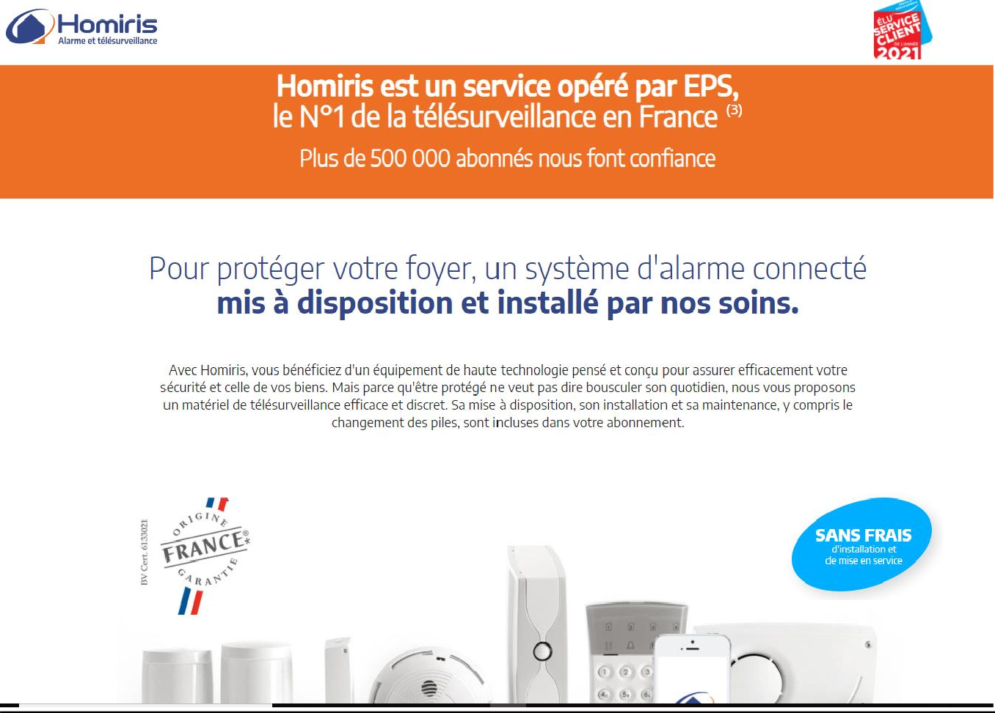

## Verisure :

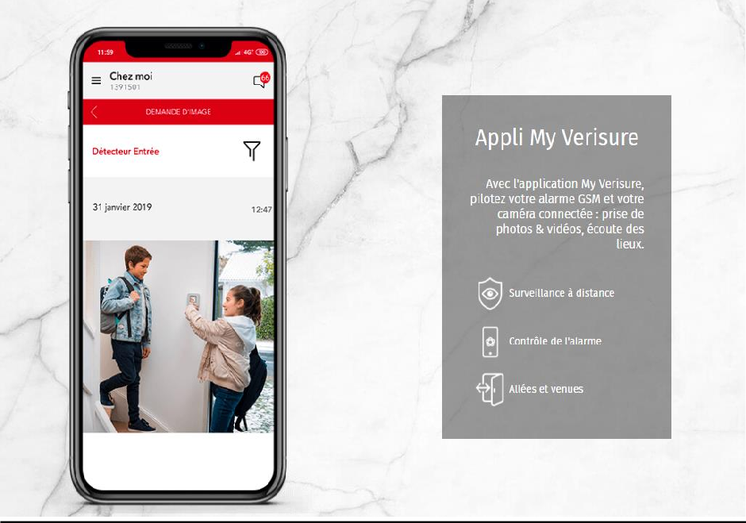

**SNS GROUPE**

# 

SNS SOLUTION NUMERIQUE SECURITE, a simplified joint stock company, has been in business for 8 years.

Located in FONTENAY-SOUS-BOIS (94120), it specializes in the sector of activities related to security systems. Its workforce is between 6 and 9 employees.

Societe.com lists 2 establishments and the last notable event of this company dates from 17-10-2019

**Sector alarm:**

With 25 years of experience and 550 000+ client across Europe, the difference between this company and the previous ones is that this company provides customized surveillance Such as temperature monitoring , smoke detection , motion detection .. etc.

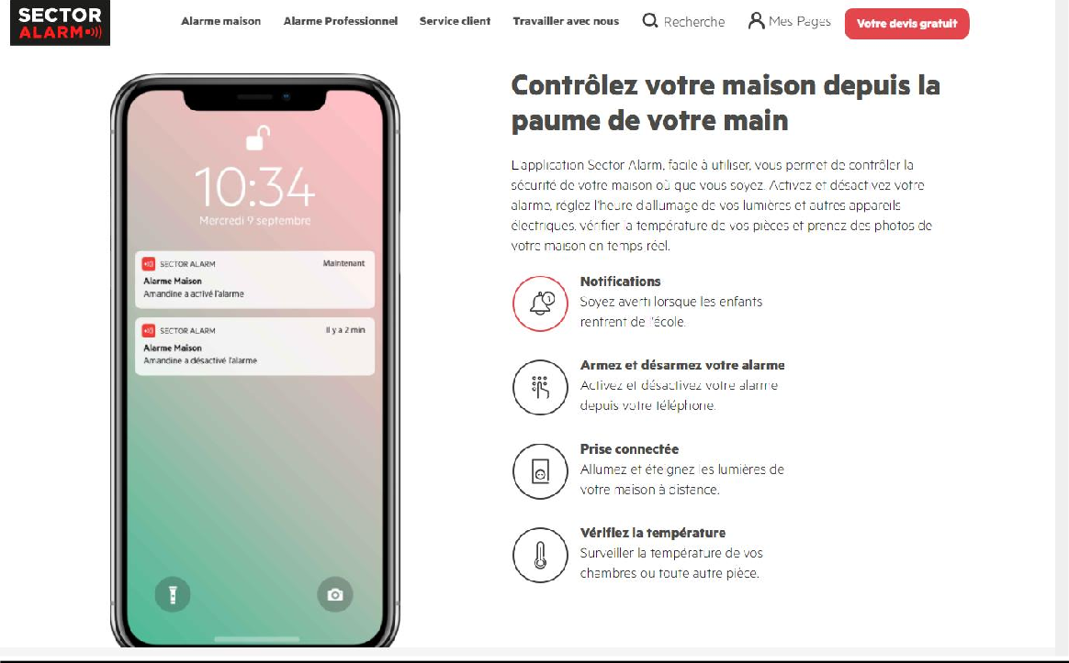

# SOMFY

# **Somfy is a French industrial group founded in 1969. Historically located in Cluses in Haute-Savoie, it is today one of the world leaders in motorization, the automation of home and building openings and alarm systems**

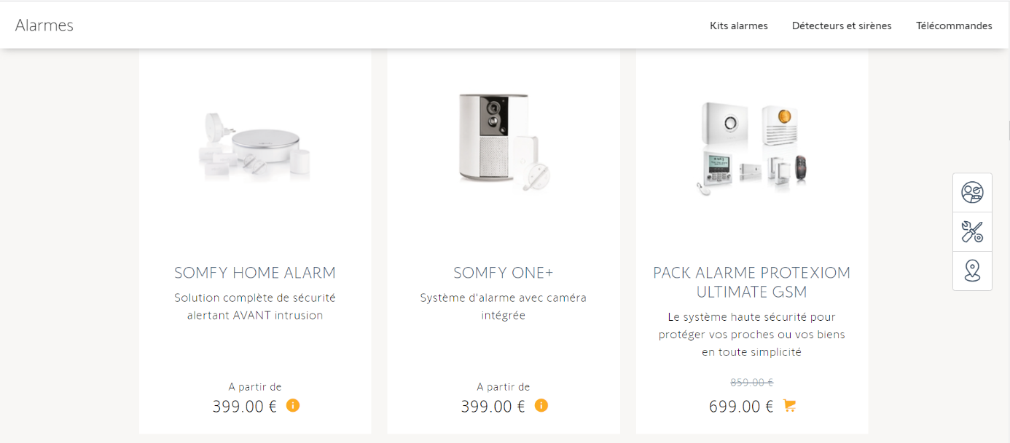

# Our system design :

## General functioning :

If the outdoor camera Is detects a movement, it will be automatically activated and the owner will be notified

Via an e-mail notification.

If the object manages to access the property the indoor camera will take a picture of the detected object and email it the owner, he then will have the choice to trigger an alarm or not. if the fingerprint authentication fails the alarm will be triggered automatically within 10 seconds.

## Sequence diagram:

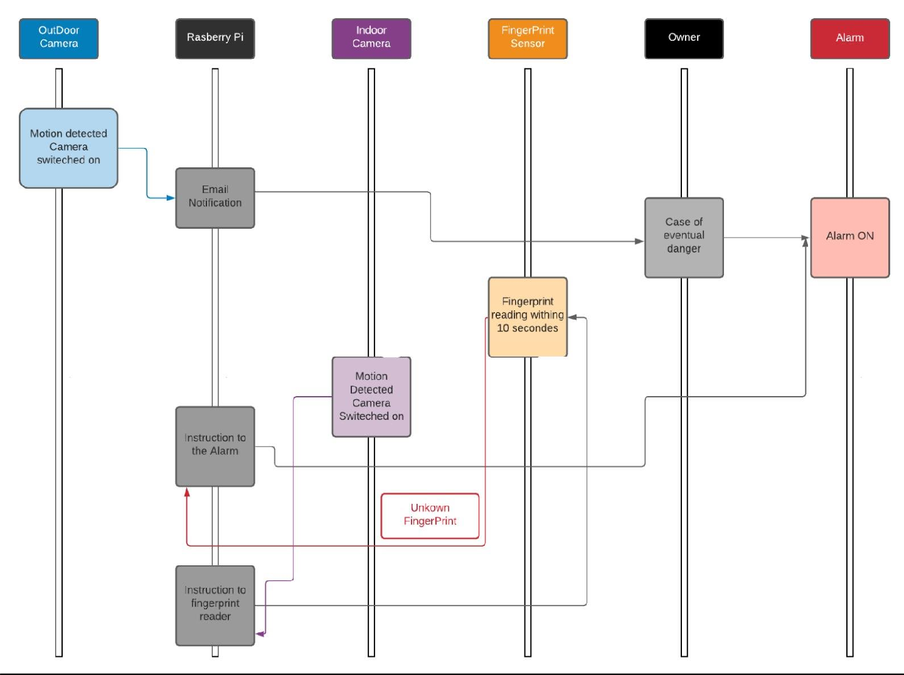

**Components:**

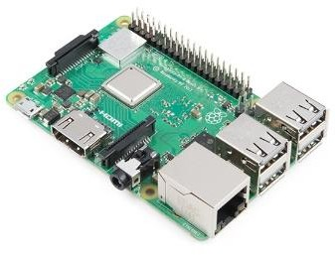

**Raspberry pi 3 B+ model**

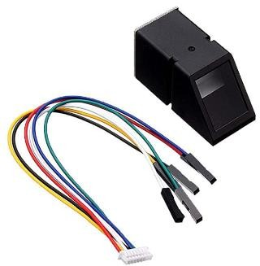

**DollaTek Blue Light Optical Fingerprint Reader**

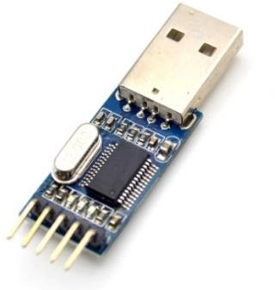

**USB to TTL convertor**

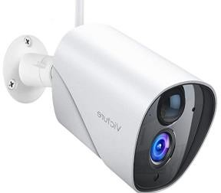

**Two Caméras : 2.4G WiFi sans Fil IP Caméra,PIR Détection de Mouvement,Audio bidirectionnel et vision**

## The difference between our system and the other systems available on the market :

Most of the surveillance systems available on the market do not provide the customer with full access to the system so he can trigger the alarm by himself instead, if the system detects a potential threat the property owner will automatically notified but the property has to be checked by a customer service agent.

This process is most of the time annoying and can represent a privacy issue for some people, since most of these systems can be used by malicious users to access to collect the owner’s data and monitor his activity.